Paired Code Review Record (Blank Template)

TechSolutions Intranet – Maintenance Log Feature

1. Review Details
Author: Aidan
Reviewer: Jahaan
Date: 29/01/2026
Files / Components Reviewed: html/css

3. Start and End Conditions
Start Condition: on the appointment screen

End Condition: appointment booked

4. Findings Checklist

A. Functionality & Logic
- HTML should specify the language

- The CSS button should have a better name
Evidence (line numbers / screenshot):
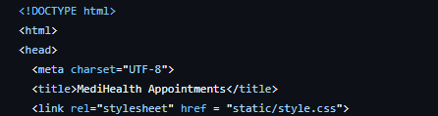
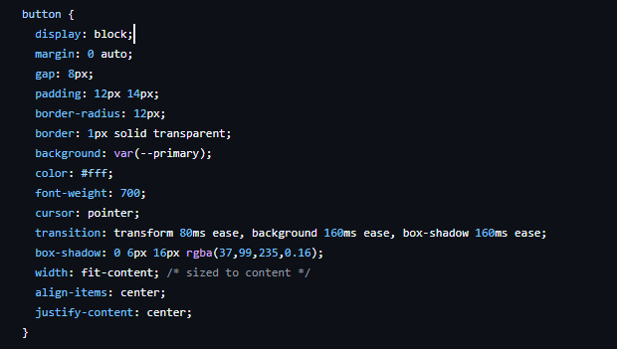

B. Code Organisation
(Naming, structure, readability, comments)
- Html should be better commented
- Structure is good
Evidence:
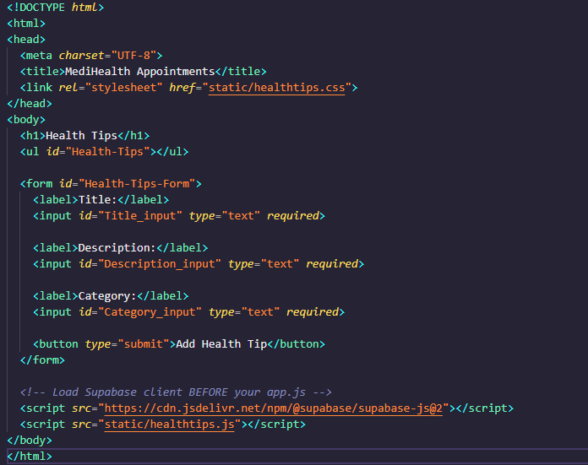

D. Efficiency
(Repeated code, unnecessary complexity, performance concerns)
- Code is fairly simple and works well

E. Data Handling & Security
(Incorrect database operations, unsafe input handling, potential leaks)
- Database is not susceptible to sql injections
- Input handling works

F. Standards, Accessibility & Legal Considerations
(Clarity of system messages, compliance with accessibility expectations, safe handling of information)
- I could have more accessibility features. E.g screen reader

5. Prioritised Improvements
Issue Identified | Proposed Fix | Priority (P1 / P2 / P3)
No comments | Add comments | P2
Html language should be specified | Specify the language | P1
Css button should have name | Name the css button | P3

6. Reviewer Summary (Short)
(Top 3 issues + impact on the system)
- comments
- css button name
- html language specified
Overall Summary:

It is good overall but should be better commented. Other than that there are not many issues. All code works well and contains input validation as well as neat code.

